2024 -2025 Fall Program Family Shout Out
In the fall sports program, the Lakeview Athletic Boosters Club publishes a section of prepaid pictures of student athletes with a message from their parents, families, grandparents, etc called a “SHOUT OUT AD.” This ad is done to show support, enthusiasm, and spirit towards the athlete for their season. The Boosters will utilize photos from team picture day for the ad. You can do a student athlete alone or a small group (such as grade level, siblings, etc).
The cost of a Shout Out Ad is $30.00 each for small pic (1/8 page).
½ Page Small Group Shout Out is $100.
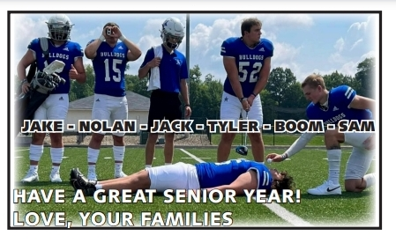
EXAMPLES:
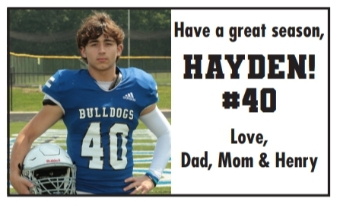

Name of student(s) in picture (Correct order not required) : _______________________________________________________________________________________________________________________________________________________________________________________________________________________________________
AD Message: ____________________________________________________________________________________________________________________________________________________________________________________________________________________________________________________________________________________________________________________
Your student must bring this form on Team Picture Day. DO NOT PUT THIS FORM AND MONEY IN THE PHOTOGRAPHY ENVELOPE. Submit form and money in a separate envelope. Checks are to be made to “Lakeview Athletic Boosters” for SHOUT OUT ADS. Text Amy Newton with any questions 330-256-3364.

Program Use Only: Frame#_____Check#___________ Cash_______ Amount Paid__________

